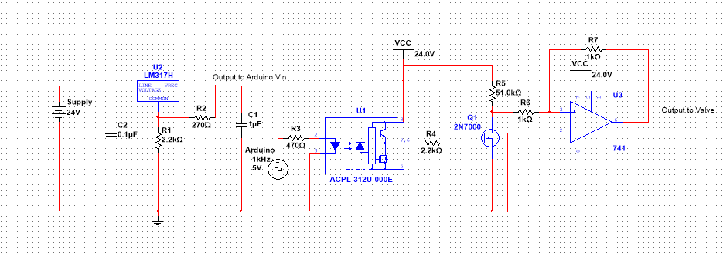

**Input/Output Voltages**

* Input Voltage: + 24 VDC (+/- 0.5 VDC)

|  |  |  |
| --- | --- | --- |
| **Schematic Element** | **IC Name/Number** | **Datasheet** |
| U1 | LM317 Linear Voltage Regulator | [https://www.onsemi.cn/PowerSolutions/document/LM317-D.PDF](https://www.infineon.com/dgdl/pvt312.pdf?fileId=5546d462533600a4015356841f1c2960) |
| SSR | PVT-312 Solid State Relay | <https://www.infineon.com/dgdl/pvt312.pdf?fileId=5546d462533600a4015356841f1c2960> |
| Q1 | 2N7000 N-Channel Small Signal MOSFET | [https://www.onsemi.com/pub/Collateral/2N7000-D.PDF](http://www.ti.com/lit/ds/symlink/ua741.pdf) |
| U2 | µA741 Single Operational Amplifier | <http://www.ti.com/lit/ds/symlink/ua741.pdf> |

* Output Voltage: +23.5 VDC (+/- 0.5 VDC)

**µA 741 General Purpose Operational Amplifier Pins**

|  |  |
| --- | --- |
| **Pin Number** | **Pin Name** |
| 1 | Offset Null |
| 2 | Inverting Input |
| 3 | Non-Inverting Input |
| 4 | V- Rail Voltage Input |
| 5 | Offset Null |
| 6 | Output |
| 7 | V+Rail Voltage Input |
| 8 | NC |

**PVT-312 Solid State Relay Pins**

|  |  |
| --- | --- |
| **Pin Number** | **Pin Name** |
| 1 | Input |
| 2 | GND |
| 3 | NC |
| 4 | VCC |
| 5 | Output |
| 6 | NC |

**LM317 Linear Voltage Regulator**

|  |  |
| --- | --- |
| **Pin Number (From Left to Right)** | **Pin Name** |
| 1 | Adjust (Common) |
| 2 | Output (VReg) |
| 3 | Input (Line Voltage) |

**2N7000 N-Channel MOSFET**

|  |  |
| --- | --- |
| **Pin Number (From Left to Right)** | **Pin Name** |
| 1 | Source |
| 2 | Gate |
| 3 | Drain |